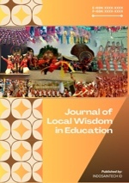

Journal of Local Wisdom in Education
https://indosainstech.id/journal/jlwe/index
https://doi.org/xxxxxxx

Title of the Article in Journal of Local Wisdom in Education
Name 1^{1*}, Name 2²
¹Department of XXX, University of XXX, City, Country
³Doctoral Student, Department of XXX, University of XXX, City, Country

Article Info |  | ABSTRACT
Article history:  Received May 15, 2025  Accepted June 08, 2025  Published Online Jun 30, 2025 |  | The abstract must be written in English using Times New Roman, 12 pt, and presented as a single paragraph containing 250–300 words. It should be concise, factual, and clearly structured to reflect the essential components of the research. Since the abstract is often the first part read by editors, reviewers, and indexing services, it must clearly communicate the intellectual value of the manuscript. Specifically, the abstract should summarize the background, urgency, research objectives, methodology, results, novelty, conclusions, and the contribution of the study to the field of local wisdom in education. References should not be included in the abstract. Avoid using non-standard abbreviations. If their use is unavoidable, define the full term at first mention
Keywords:
Character education
Deep learning
Local wisdom
Sipakalebbi
Sipakatau
This is an open access under the CC-BY-SA license.


Corresponding author:
Name:
Email:

INTRODUCTION
This is a guideline for an article in the Journal of Local Wisdom in Education (JLWE). The article should be in the softcopy format of A4 paper size format. Margin: Top = 3 cm, bottom = 2 cm, left = 3 cm, right= 2 cm. The article contains between 5000 and 8000 words, including tables, references, and image descriptions. Line spacing: 1.5
The Introduction must explain why the study is important. This section should not merely provide a general background; it should develop a clear scholarly argument that leads to the research objective. The Introduction is expected to guide readers from the broader educational or cultural issue to the specific problem addressed in the study: (a) Provide a relevant background of the study; (b) Identify the research problem clearly; (c) Explain the significance and urgency of the study; (d) Provide a focused review of relevant prior studies; (e) Present the gap analysis or novelty statement; (f) Conclude with a clear statement of the research objective and, where appropriate, research questions.
The organization and citation of the bibliography are made in the American Psychological Association 7th. The terms in foreign languages are written in italic. Authors are suggested to present their articles in the section structure: Introduction – Method – Results – Discussion – Conclusion - References.
For example, character education has emerged as a critical component of primary education worldwide, especially as societies confront growing concerns about moral degradation, social disconnection, and the erosion of empathy among younger generations (Salmia et al., 2023; Kadir & Rosmini, 2025). In response to these challenges, educators and policymakers have increasingly emphasized the need to cultivate students' ethical, emotional, and interpersonal capacities alongside academic proficiency. In Indonesia, character education has become a national priority, formalized by Presidential Regulation No. 87 of 2017, which strengthens character education and mandates the integration of moral values into school curricula (Aswat et al., 2021). The regulation calls for education systems to develop not only intellectually competent but also morally sound individuals who can engage constructively in diverse societies. However, realizing this vision requires pedagogical strategies that go beyond declarative instruction and foster deep moral internalization through reflective, culturally relevant learning experiences.

METHODS
The Methods section must clearly explain how the study was conducted so that readers can evaluate its rigor and, where relevant, replicate it. Depending on the research design, the Methods section should include the research approach, setting, participants or data sources, sampling or selection procedures, instruments, data collection procedures, data analysis techniques, and strategies for validity, reliability, trustworthiness, or credibility.
For example, this study employs a qualitative research approach to explore the integration of local wisdom values—Sipakatau and Sipakalebbi—within the deep learning approach for character education in elementary schools. Qualitative content analysis was selected because it enables in-depth exploration of conceptual relationships and theoretical frameworks, particularly for understanding abstract constructs such as character values, cultural pedagogy, and student moral development (Creswell & Creswell, 2018). This approach is consistent with prior educational studies that emphasize the value of interpretive methods for analyzing sociocultural phenomena in learning environments (Vygotsky, 1978). Figure 1 shows the Stages of content analysis in the systematic literature review process.
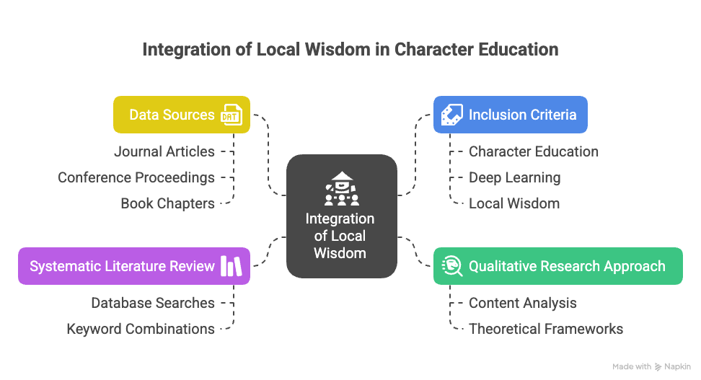
Figure 1. Stages of content analysis in the systematic literature review process

Following the collection and filtering of sources, a content analysis technique was employed to categorize and interpret recurring themes, arguments, and educational models. The analytic process consisted of four key stages: selection of literature, evaluation of source credibility, thematic coding, and synthesis of conceptual relationships. This method aligns with xxxxx (2023) the assertion that meaningful learning involves connecting theoretical knowledge to existing cognitive structures and real-life experiences. As shown in Table 1, the literature was systematically analyzed to identify patterns and theoretical convergence among themes of local wisdom, deep learning, and moral development in students.
Table 1. Analytical framework for literature coding and thematic categorization
Aspect | Result | Analysis
Definition | Findings derived from selected literature sources | Interpretation of recurring themes and theoretical relationships
Focus | Integration of Sipakatau and Sikalalebbi in deep learning pedagogy | Cross-analysis of literature to assess conceptual alignment with study objectives
Examples | Cultural narrative-based learning; experiential value-based activities | Mapping best practices and previous models to assess implementation feasibility
Process | Selection, screening, coding, and interpretation of sources | Ensures methodological transparency and content validity
Output | Conceptual framework for localized character education models | Synthesis of values and strategies supporting integrative, reflective learning

RESULTS
The results section presents the findings of the study in a clear, focused, and organized manner. Results must directly address the research objective(s) or research questions stated in the Introduction
Tables and figures should be used only when they improve clarity and help readers understand the results more effectively. Visual materials must be relevant, accurate, and clearly labeled. (a) Every table and figure must be mentioned in the text; (b) Number tables and figures consecutively; (c) Table titles should be placed above the table; (d) Figure captions should be placed below the figure; (e) Avoid duplicating identical information in both the text and a table or figure; (f) Ensure that tables and figures are readable in black-and-white printing as well as on screen; (g) Use high-quality images and diagrams.
- Point A
The results section presents the findings of the study in a clear, focused, and organized manner. Results must directly address the research objective(s) or research questions stated in the Introduction.
Results may be presented through narrative explanation, tables, figures, diagrams, or other visual formats. The points to note in the results section are: (a) Report the most important findings clearly; (b) Avoid presenting raw data without analytical direction; (c) Ensure that tables and figures are relevant and readable; (d) Avoid duplicating exactly the same information in both the text and visual displays.
- Point B
The results section presents the findings of the study in a clear, focused, and organized manner. Results must directly address the research objective(s) or research questions stated in the Introduction
Tables and figures should be used only when they improve clarity and help readers understand the results more effectively. Visual materials must be relevant, accurate, and clearly labeled. The points to note about Tables and figures are: (a) Every table and figure must be mentioned in the text; (b) Number tables and figures consecutively; (c) Table titles should be placed above the table; (d) Figure captions should be placed below the figure; (e) Avoid duplicating identical information in both the text and a table or figure; (f) Ensure that tables and figures are readable in black-and-white printing as well as on screen; (g) Use high-quality images and diagrams.

DISCUSSION
The discussion should focus on the significance and implications of the findings rather than merely repeating the results. Findings must be discussed in relation to the stated objectives and hypotheses, and their broader relevance should be explained. Comparisons with the findings of previous studies must also be included.
The Discussion section is the place where authors interpret the meaning and significance of the findings. This section should not simply repeat the Results. Instead, it should explain how and why the findings matter in relation to the research objectives, theories, and prior studies. Interpret the key findings in relation to the research objective(s). The points to note in the discussion section are: (a) Explain how the findings answer the research problem; (b) Connect the findings with relevant theories and prior studies; (c) Show whether the findings confirm, extend, challenge, or refine existing knowledge; (d) Discuss the educational, cultural, theoretical, or practical implications; (e) Demonstrate how the study contributes to scholarship on local wisdom in education.

CONCLUSION
The conclusion should provide a concise synthesis of the main findings of the study. It should directly answer the research objective(s) and highlight the contribution of the article. It should also acknowledge limitation(s) and provide recommendations for future research and, when relevant, educational practice or policy.

Acknowledgements: This section may be used to recognize financial support, institutional assistance, community participation, or contributions from individuals who do not meet the criteria for authorship. If the study was supported by a grant or institutional funding, the funding source and grant number should be stated here.
Data availability: Where relevant, authors are encouraged to include a brief statement regarding the availability of the data supporting the findings of the study. Examples may include availability upon reasonable request, inclusion within the article, or deposit in a repository.
Conflict of Interest: Authors must disclose any conflict of interest related to the manuscript. If there is no conflict of interest, authors may state: “The authors declare that there is no conflict of interest regarding the publication of this article.”

REFERENCES
The following are the reference writing guidelines for the Journal of Local Wisdom in Education. All references must be arranged alphabetically and formatted according to the American Psychological Association (APA) 7th Edition style. Authors are strongly encouraged to use reference management tools such as Mendeley, Zotero, or EndNote. A minimum of 85% of the cited references must be published within the last 10 years, and at least 85% must be sourced from international peer-reviewed journals. This ensures that the article is grounded in recent and globally relevant scholarship.
Examples of References in APA Style 7
Journal article with DOI
Rosa, M., & Orey, D. C. (2024). Exploring cultural dynamism of ethnomodelling as a pedagogical action for students from minority cultural groups. ZDM–Mathematics Education, 56(3), 423–434.https://doi.org/10.1007/s11858-023-01539-7
Journal article without DOI
Badeni, B., & Saparahayuningsih, S. (2023). The implementation of local wisdom-based character education in elementary school. Journal of Educational Issues, 9(2), 1–14.
Book
Creswell, J. W., & Creswell, J. D. (2018). Research design: Qualitative, quantitative, and mixed methods approaches (5th ed.). SAGE Publications.
Edited book
D’Ambrosio, U., & Rosa, M. (Eds.). (2021). Ethnomathematics and its diverse approaches for mathematics education. Springer.
Chapter in an edited book
Rosa, M., & Orey, D. C. (2021). Ethnomodelling as the translation of diverse cultural mathematical practices. In L. N. Huynh, K. Hostinska, & J. S. Vitter (Eds.), Handbook of the mathematics of the arts and sciences (pp. 2607–2635). Springer. https://doi.org/10.1007/978-3-319-57072-3_70
Proceedings paper / conference paper
Hikmah, A. F., Faiziyah, N., & Ishartono, N. (2024). Implementation of ethnomathematics-oriented problem-based learning to improve student activities and learning outcomes. In AIP Conference Proceeding (Vol. 2926, p. 020001). AIP Publishing. https://doi.org/10.1063/5.0183046
Thesis or dissertation
Sulaiman, F. (2011). The effectiveness of problem-based learning (PBL) online on students’ creative and critical thinking in physics at tertiary level in Malaysia [Doctoral thesis, University of Waikato]. University of Waikato Research Commons.
Report
UNESCO. (2023). Reimagining education in culturally diverse societies. UNESCO Publishing.

About the Authors

Photo | Full Name, Academic Degree(s). is currently working as [current position] at [department/institution, city, country]. He/She earned his/her [highest degree] in [field of study] from [university name]. His/Her research interests include [research areas].  Email: [email address]  ORCID ID: [ORCID link]
Photo | Full Name, Academic Degree(s). is a teacher at [school name], [city, country]. He/She earned his/her [highest degree] in [field of study] from [university name]. His/Her professional and research interests include [research areas].  Email: [email address]  ORCID ID: [ORCID link]

